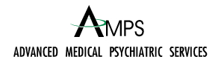

AUTHORIZATION FOR AUTOMATED BILL PAYMENT PROGRAM

Auto draft by Visa/Mastercard

Please return this form to: Advanced Medical Psychiatric Services, 3409 Calloway Drive, Suite 601, Bakersfield, CA 93312

Patient Name:

Address:

Primary Telephone Number:

Email:

Visa/Mastercard Draft

Visa/Mastercard Number: Security Code:

Name on Card: Expiration Date:
(Exactly as it appears on card)

Mailing address your card statements are received:

City State Zip Code

I, , authorize Advanced Medical Psychiatric Services to obtain an automatic payment on my account in the amount of $ on the day of my scheduled or $ 35 if I fail to cancel my appointment in less than 24 hours notice.

Signature (REQUIRED) Date

